

**Implementation of Linear Regression AND Implementation of Linear Regression with Polynomial**

**ABUBAKAR ASIF**

**#AbubakarAsif FA20-BCE-013**

**#abubakarasif3111@gmail.com**

**#https://github.com/Abubakar3111**

**#https://www.linkedin.com/in/abubakar-asif-b3b94021a/**

**Artificial Intelligence**

**# Implementation of Linear Regression**

*print("Abubakar Asif")*

*import numpy as np*

*import pandas as pd*

*import matplotlib.pyplot as plt*

*import numpy.linalg as LA*

*from sklearn.linear_model import LinearRegression*

*from sklearn.metrics import mean_squared_error*

*from sklearn.preprocessing import PolynomialFeatures*

*data = pd.read_csv('marks.csv')*

*print(data.shape)*

*print(data)*

*x1 = data['Quiz'].values*

*x2 = data['Assg'].values*

*x3 = data['Mid'].values*

*Y = data['Final'].values*

*m = len(x1)*

*# plt.scatter(x1,Y)*

*# plt.xlabel('Quiz')*

*# plt.ylabel("Final")*

*x1 = x1.reshape(m)*

*x2 = x2.reshape(m)*

*x3 = x3.reshape(m)*

*# poly_features = PolynomialFeatures(degree = 4)*

*# X1 = poly_features.fit_transform(x1)*

*# poly_features = PolynomialFeatures(degree = 4)*

*# X2 = poly_features.fit_transform(x2)*

*# poly_features = PolynomialFeatures(degree = 4)*

*# X3 = poly_features.fit_transform(x3)*

*ax = plt.axes(projection ='3d')*

*ax.scatter(x1, x2, Y)*

*x0=np.ones(m)*

*X=np.array([x0,x1,x2,x3]).T*

*print(X)*

*reg=LinearRegression()*

*reg.fit(X,Y)*

*h_theta=reg.predict(X)*

*print("Abubakar Asif")*

*quiz=78*

*Assg=83*

*Mid=77*

*presal=reg.predict( [[1,quiz,Assg,Mid]])*

*print("\nMy Output\n")*

*print(presal)*

*print("\nActual Output:160")*

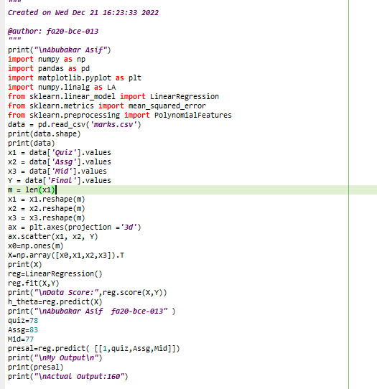

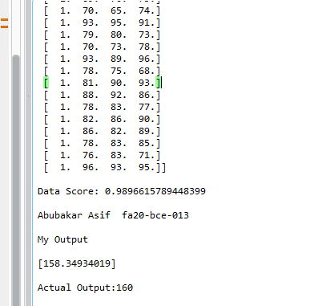

**# Implementation of Linear Regression with Polynomial**

*# -- coding: utf-8 --*

*"""*

*Created on Wed Dec 21 16:23:33 2022*

*@author: fa20-bce-013*

*"""*

*print("\nAbubakar Asif")*

*import numpy as np*

*import pandas as pd*

*import matplotlib.pyplot as plt*

*import numpy.linalg as LA*

*from sklearn.linear_model import LinearRegression*

*from sklearn.metrics import mean_squared_error*

*from sklearn.preprocessing import PolynomialFeatures*

*data = pd.read_csv('marks.csv')*

*print(data.shape)*

*print(data)*

*x1 = data['Quiz'].values*

*x2 = data['Assg'].values*

*x3 = data['Mid'].values*

*Y = data['Final'].values*

*m = len(x1)*

*x1 = x1.reshape(m)*

*x2 = x2.reshape(m)*

*x3 = x3.reshape(m)*

*ax = plt.axes(projection ='3d')*

*ax.scatter(x1, x2, Y)*

*x0=np.ones(m)*

*X=np.array([x0,x1,x1**2,x2,x2**2,x3,x3**2]).T*

*print(X)*

*reg=LinearRegression()*

*reg.fit(X,Y)*

*print("\nData Score:",reg.score(X,Y))*

*h_theta=reg.predict(X)*

*print("\nAbubakar Asif fa20-bce-013" )*

*quiz=78*

*Assg=83*

*Mid=77*

*presal=reg.predict( [[1,quiz,quiz**2,Assg,Assg**2,Mid,Mid**2]])*

*print("\nMy Output\n")*

*print(presal)*

*print("\nActual Output:160")*

